# Sri Lanka Institute of Information

# Technology



## Lab Submission

## Lab sheet No 09

## 

**IT24103868**

**Jayasekara V.D.N**

**IT2120 - Probability and Statistics**

B.Sc. (Hons) in Information Technology

### Exercise

1. Assume that the time taken to bake a batch of cookies is normally distributed with mean 45 minutes and standard deviation 2 minutes.

1. Generate a random sample of size 25 for the baking time.

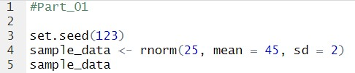

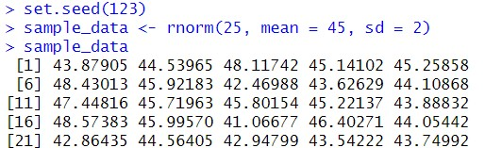

1. Test whether the average baking time is less than 46 minutes at a 5% level of significance.

